8. RESULTS

International Flight screen:

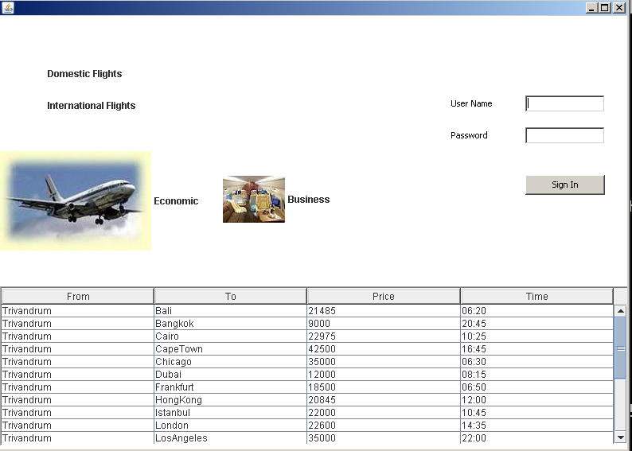

Figure: 8.1

Domestic Flight Screen:

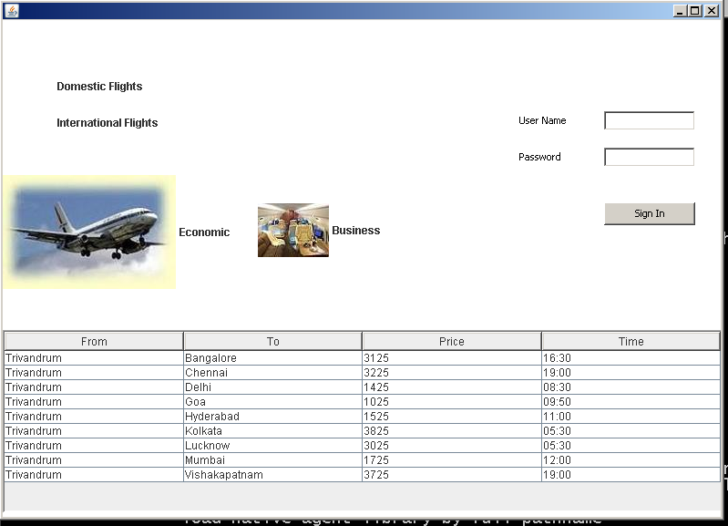

Figure:8.2

Login Screen:

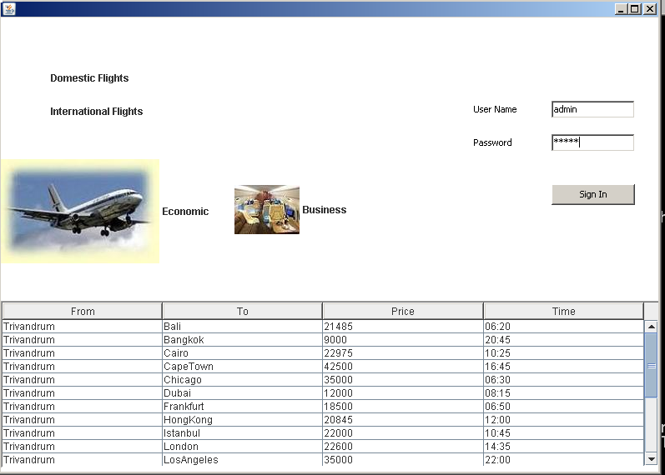

Figure:8.3

Logged In screen:

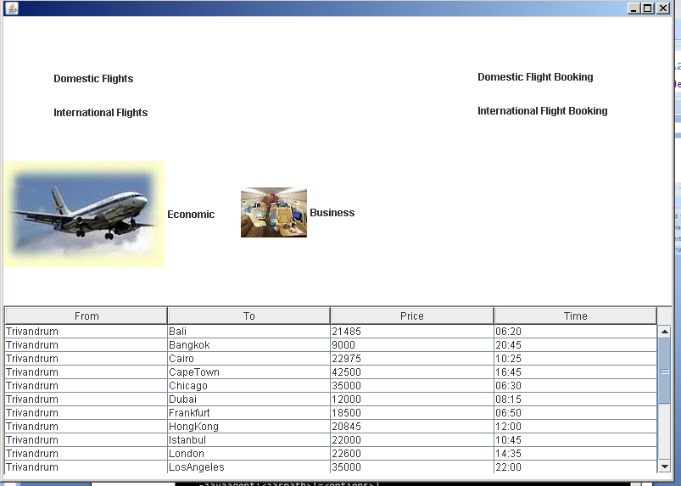

Figure:8.4

Domestic Flight Booking screen:

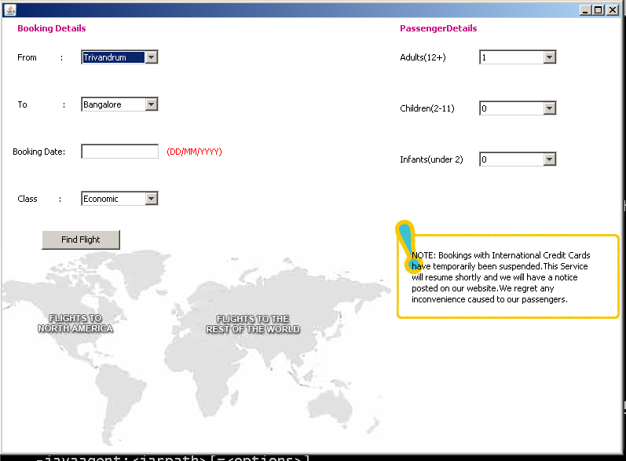

Figure:8.5

For booking a flight:

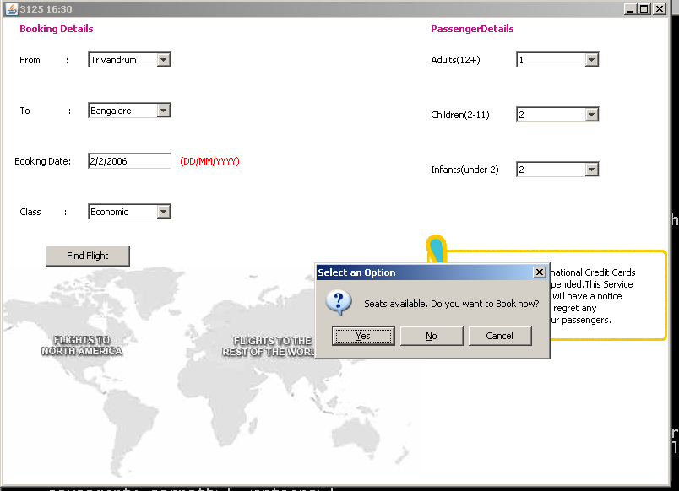

Figure:8.6

Booked Flight screen:

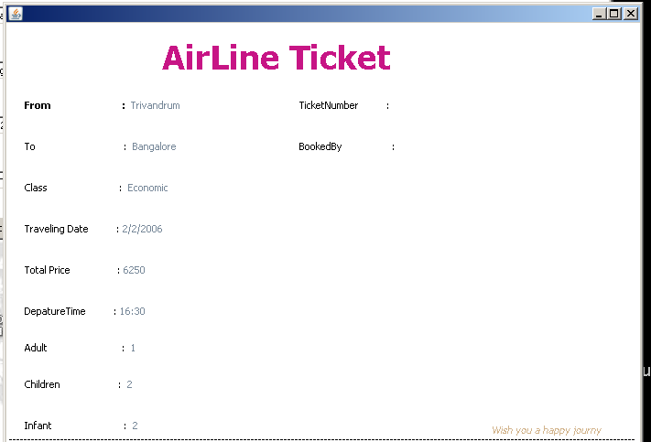

Figure:8.7

International Flight Booking screen:

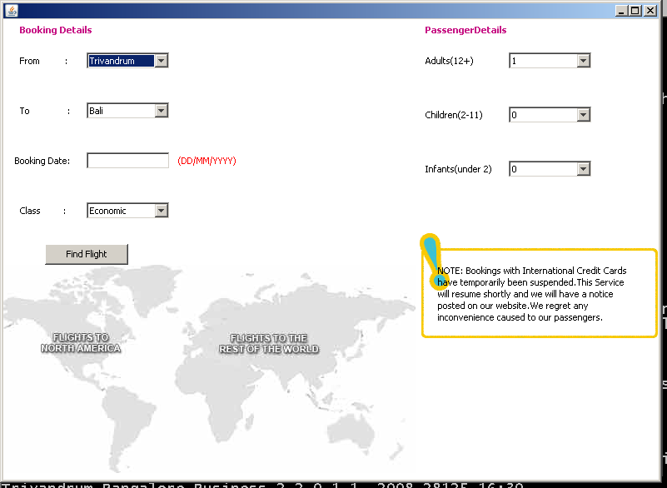

Figure:8.8

If booked :

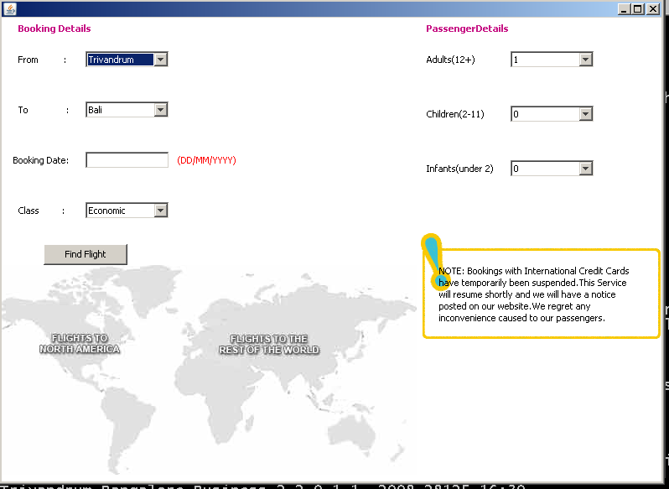

Figure:8.9

Booked Flight screen:

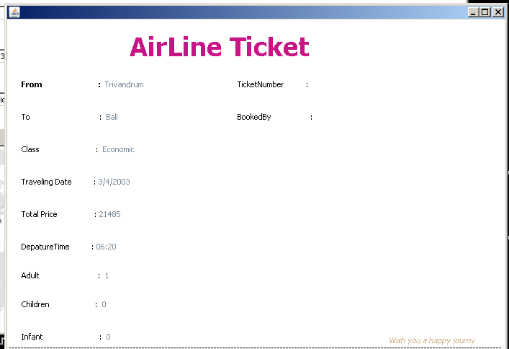

Figure:8.10

